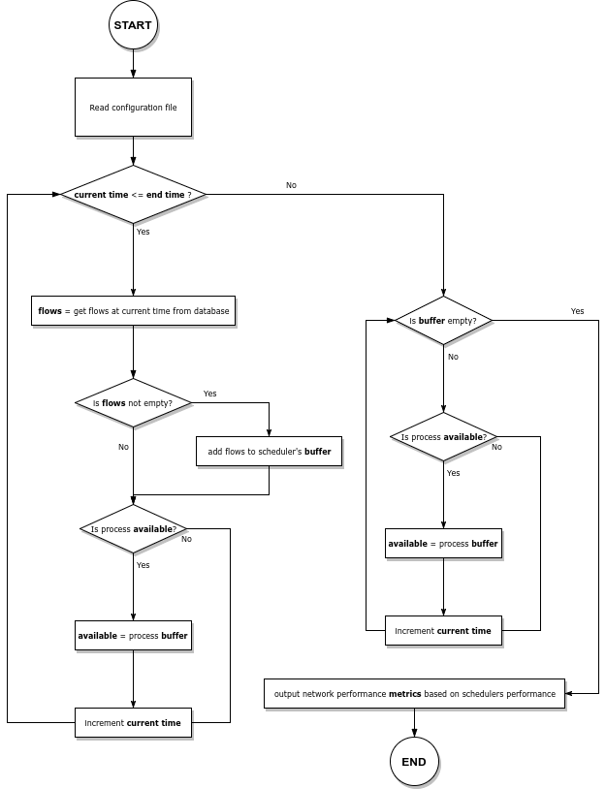
METHODOLOGY
The program logic is described in the flow chart below.

